# Test cases

| TITLE | PRECONDITIONS | STEPS | EXPECTED RESULT | COMMENT |
| --- | --- | --- | --- | --- |
| Verify registration with valid information | <https://petstore.octoperf.com/actions/Catalog.action> is opened | 1. Click on the “Sign In” button 2. Click on the “Register Now!” button 3. Populate fields with valid information 4. Click on the “Save Account information” button | The user is successfully registered and redirected to the home page. | This test case is crucial for the main application functionality as products can not be purchased if the user is not registered. |
| Verify registration without populating required fields | <https://petstore.octoperf.com/actions/Catalog.action> is opened | 1. Click on the “Sign In” button 2. Click on the “Register Now!” button 3. Do not populate any fields 4. Click on the “Save Account information” button | Validation messages for the required fields should be triggered. | Validation messages will direct the user's focus to the mandatory fields that need to be filled. |
| Verify registration with an existing User ID | <https://petstore.octoperf.com/actions/Catalog.action> is opened | 1. Click on the “Sign In” button 2. Click on the “Register Now!” button 3. Enter an existing user ID in the “User ID” field 4. Populate the rest of the fields with valid information 5. Click on the “Save Account information” button | Error message “User ID already exists” should be displayed. | The user ID must be unique for every user. |
| Verify registration with an invalid email format | <https://petstore.octoperf.com/actions/Catalog.action> is opened | 1. Click on the “Sign In” button 2. Click on the “Register Now!” button 3. Fill the “Email” field with an invalid email format e.g. test.test.com 4. Populate the rest of the fields with valid information 5. Click on the “Save Account information” button | Error message “Invalid email format, please try again” should be displayed. | Valid email format is important for account verification or in the case of password reset. |
| Verify login with valid credentials | * user is registered * <https://petstore.octoperf.com/actions/Catalog.action> is opened | 1. Click on the “Sign In” button 2. Enter valid username and password 3. Click on the “Login” button | The user is successfully logged in. | Very important test case because products can not be purchased if the user is not logged in. |
| Verify login without populating username and password fields | * user is registered * <https://petstore.octoperf.com/actions/Catalog.action> is opened | 1. Click on the “Sign In” button 2. Click on the “Login” button | “Invalid username or password” error message should be displayed. | Users must be informed about mandatory fields. |
| Verify login with an invalid username | * user is registered * <https://petstore.octoperf.com/actions/Catalog.action> is opened | 1. Click on the “Sign In” button 2. Enter invalid username 3. Enter valid password 4. Click on the “Login” button | “Invalid username or password” error message should be displayed. | It’s important that the error message does not reveal whether the username or the password is incorrect. It’s much harder to hack someone's account this way. |
| Verify login with an invalid password | * user is registered * <https://petstore.octoperf.com/actions/Catalog.action> is opened | 1. Click on the “Sign In” button 2. Enter valid username 3. Enter invalid password 4. Click on the “Login” button | “Invalid username or password” error message should be displayed. |  |
| Search pets by name | <https://petstore.octoperf.com/actions/Catalog.action> is opened | 1. Enter e.g. “bulldog” in the search field 2. Click on the “Search” button | Pets that contain the searched term should be displayed. | Searching by name is really useful for finding the correct product. |
| Search pets by product ID | <https://petstore.octoperf.com/actions/Catalog.action> is opened | 1. Enter the product ID for a specific pet 2. Click on the “Search” button | The pet with a searched product ID should be displayed. | Searching by product ID is the quickest way of finding the specific product. |
| Add a pet to the cart | * user is logged in * [petstore.octoperf.com/](https://petstore.octoperf.com/actions/Catalog.action) is opened | 1. Click on “Fish” in the left sidebar 2. Click on any Product ID 3. Click on the “Add to cart” button | Selected item should be present in the shopping cart. | It's important that the correct item is added to the shopping cart. |
| Remove a pet from the shopping cart | * user is logged in * <https://petstore.octoperf.com/actions/Catalog.action> is opened | 1. Click on “Fish” in the left sidebar 2. Click on any Product ID 3. Click on the “Add to cart” button 4. Click on the “Remove” button | Removed item should not be displayed in the shopping cart. | The user should be able to remove the unwanted item from the shopping cart. |
| Update item quantity in a shopping cart | * user is logged in * <https://petstore.octoperf.com/actions/Catalog.action> is opened | 1. Click on “Fish” in the left sidebar 2. Click on any Product ID 3. Click on the “Add to cart” button 4. Enter 2 in a “Quantity” field 5. Click on the “Update cart” button | “Subtotal” and “Total Cost” amounts should be updated according to the entered quantity. | The correct price must be displayed for different product quantities. |
| Verify checkout with valid information | * user is logged in * <https://petstore.octoperf.com/actions/Catalog.action> is opened | 1. Click on “Fish” in the left sidebar 2. Click on any Product ID 3. Click on the “Add to cart” button 4. Click on the “Proceed to checkout” button 5. Populate fields with valid information 6. Click on the “Continue” button 7. Click on the “Confirm” button | “Thank you, your order has been submitted.” message should be displayed with order information. | User must be able to successfully purchase selected items. |
| Verify checkout without populating required fields | * user is logged in * <https://petstore.octoperf.com/actions/Catalog.action> is opened | 1. Click on “Fish” in the left sidebar 2. Click on any Product ID 3. Click on the “Add to cart” button 4. Click on the “Proceed to checkout” button 5. Do not populate any fields 6. Click on the “Continue” button | Validation messages for the required fields should be triggered. | Validation messages will notify the user which fields are mandatory. |
| Verify checkout with invalid card information | * user is logged in * <https://petstore.octoperf.com/actions/Catalog.action> is opened | 1. Click on “Fish” in the left sidebar 2. Click on any Product ID 3. Click on the “Add to cart” button 4. Click on the “Proceed to checkout” button 5. Enter invalid card number 6. Populate the rest of the fields with valid information 7. Click on the “Continue” button | Error message “Payment details are not correct, please try again” should be displayed. | Only payments with valid payment details should be able to complete the checkout flow. |

Exploratory testing

# **Console error 500 is displayed while trying to submit the registration form after populating only the “User Information” section**

## **Steps to reproduce:**

1. Open <https://petstore.octoperf.com/actions/Catalog.action>
2. Click on the “Sign in” button
3. Click on the “Register now” button
4. Enter anything in the “User ID” field e.g. “test”
5. Enter anything in the “New password” field e.g. “test”
6. Enter anything in the “Repeat password” field e.g. “test”
7. Click on the “Save Account Information” button

**Actual result:**Console error 500 is displayed.

## **Expected result:** Validation messages for the required fields should be triggered.

**Noticed on:**Google Chrome 118.0.5993.118 - Windows 11

**Screencast:**<https://drive.google.com/file/d/1zO8SNMR09o7wL7gUpZEkNTtFjYGhOJ-n/view?usp=sharing>

# **Console error 500 is displayed after trying to complete registration with an already registered User ID**

## **Steps to reproduce:**

1. Open <https://petstore.octoperf.com/actions/Catalog.action>
2. Click on the “Sign in” button
3. Click on the “Register now” button
4. Enter “test11” in the “User ID” field
5. Fill the form with valid information
6. Click on the “Save Account Information” button
7. Notice that the registration is successful
8. Navigate again to the “Registration” page
9. Enter the same “test11” in the “User ID” field
10. Fill the form with valid information
11. Click on the “Save Account Information” button

**Actual result:**Console error 500 is displayed.

## **Expected result:** Error message “User ID already exists, please choose another one.” should be displayed.

**Noticed on:**Google Chrome 118.0.5993.118 - Windows 11

**Screencast:**<https://drive.google.com/file/d/1nPxFJfGfaSUjU43q8iVhIYgOW0OS5dcs/view?usp=sharing>

# **The navigation bar is missing on the “Help” page**

## **Steps to reproduce:**

1. Open <https://petstore.octoperf.com/actions/Catalog.action>
2. Click on the question mark in the navigation bar

**Actual result:**The navigation bar is missing from the top of the page.

## **Expected result:** The navigation bar is present and functional.

**Noticed on:**Google Chrome 118.0.5993.118 - Windows 11

**Screenshot:**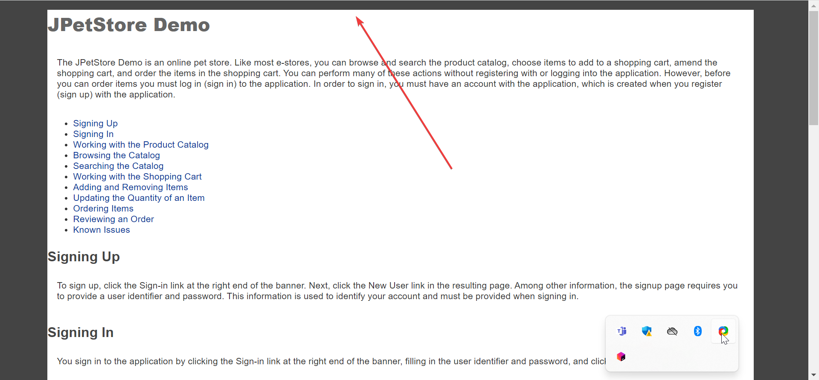

# **The “Known Issues” link is not working on the “Help” page**

## **Steps to reproduce:**

1. Open <https://petstore.octoperf.com/actions/Catalog.action>
2. Click on the question mark in the navigation bar
3. Click on the “Known Issues” link

**Actual result:**Nothing happens. The top of the page remains displayed.

## **Expected result:** The“Help” page should be scrolled to the “Known Issues” section.

**Noticed on:**Google Chrome 118.0.5993.118 - Windows 11

**Screencast:**<https://drive.google.com/file/d/1QVRwKu-j5Z4H6IlS1JM5RISZ-vEYUPiV/view?usp=sharing>

# **The “Update cart” button remains displayed after removing items from the shopping cart**

## **Steps to reproduce:**

1. Open <https://petstore.octoperf.com/actions/Catalog.action>
2. Click on “Fish” in the left sidebar
3. Click on any Product ID
4. Click on the “Add to cart” button
5. Click on the “Remove” button

**Actual result:**The “Update cart” button remains displayed. Nothing happens after clicking on the “Update cart” button.

## **Expected result:** The “Update cart” button should be removed until a new item is added to the shopping cart.

**Noticed on:**Google Chrome 118.0.5993.118 - Windows 11

**Screencast:**<https://drive.google.com/file/d/1YFokVY9L_Bxvg9UBUeatqxor3TdNQvPx/view?usp=sharing>

# **“Please enter a keyword to search for, then press the search button.” message is duplicated after clicking on the “Search” button**

## **Steps to reproduce:**

1. Open <https://petstore.octoperf.com/actions/Catalog.action>
2. Leave the search input field empty
3. Click on the “Search” button in the top right corner

**Actual result:**Two “Please enter a keyword to search for, then press the search button.” messages are displayed.

## **Expected result:** A single “Please enter a keyword to search for, then press the search button.” message should be displayed.

**Noticed on:**Google Chrome 118.0.5993.118 - Windows 11

**Screenshot:  
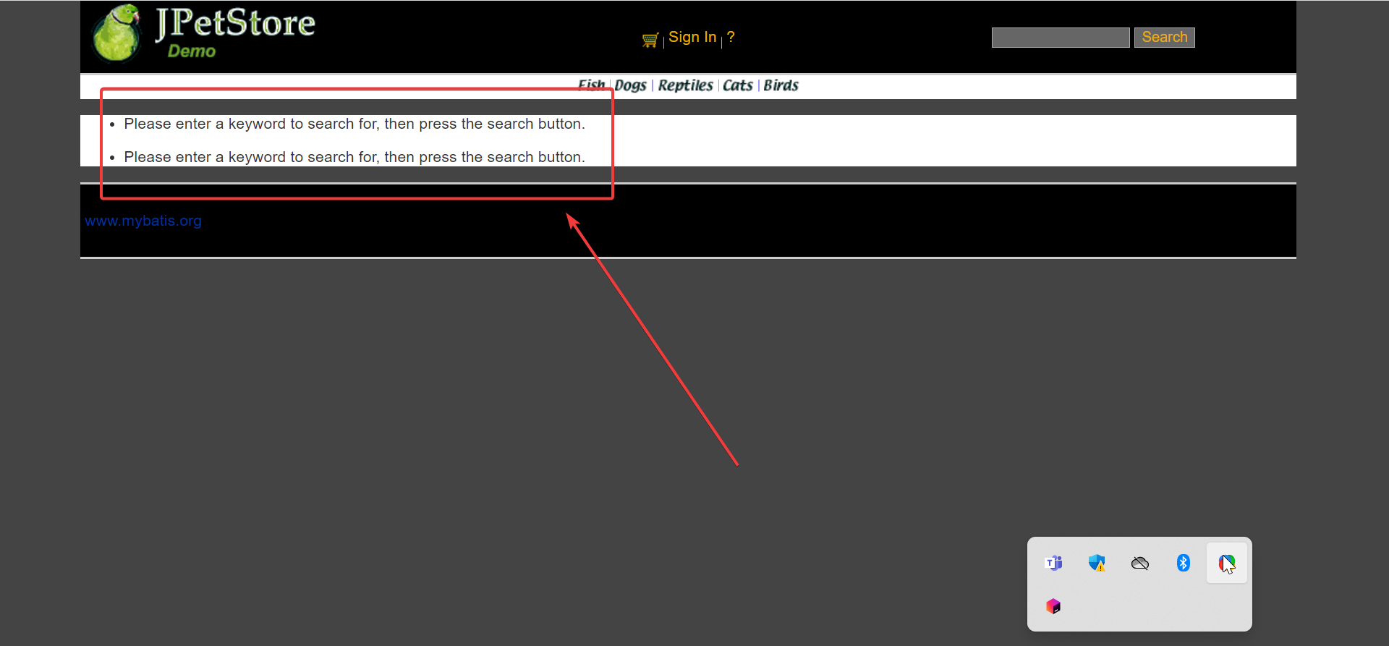**

# **Field validations are missing on the “Registration” page**

## **Steps to reproduce:**

1. Open <https://petstore.octoperf.com/actions/Catalog.action>
2. Click on the “Sign in” button
3. Click on the “Register now” button
4. Click on the “Save Account Information” button

**Actual result:**Nothing happens. None of the mandatory field validation is triggered.

## **Expected result:** Field validations should be triggered for all mandatory fields.

**Noticed on:**Google Chrome 118.0.5993.118 - Windows 11

**Screencast:**<https://drive.google.com/file/d/15ivQg5ygAHaWhASHy9L4EGztSKWZfqhL/view?usp=sharing>

# **User is able to submit the registration form without the matching “New password” and “Repeat password” input values**

## **Steps to reproduce:**

1. Open <https://petstore.octoperf.com/actions/Catalog.action>
2. Click on the “Sign in” button
3. Click on the “Register now” button
4. Enter e.g. “test” in the “New password” field
5. Enter e.g. “testtest” in the “Repeat password” field
6. Fill the rest of the fields with valid information
7. Click on the “Save Account Information” button

**Actual result:**User is successfully registered.

## **Expected result:** Error message “New password and Repeat password are not matching.” should be displayed.

**Noticed on:**Google Chrome 118.0.5993.118 - Windows 11

**Screencast:**<https://drive.google.com/file/d/1KlIW6iBjbv6by6IjIJRPkr-_7z096Iky/view?usp=sharing>

# **User is able to submit the registration form with the invalid email format**

## **Steps to reproduce:**

1. Open <https://petstore.octoperf.com/actions/Catalog.action>
2. Click on the “Sign in” button
3. Click on the “Register now” button
4. Enter e.g. “test” in the “Email” field
5. Fill the rest of the fields with valid information
6. Click on the “Save Account Information” button

**Actual result:**User is successfully registered.

## **Expected result:** Error message “Email format is not correct” should be displayed.

**Noticed on:**Google Chrome 118.0.5993.118 - Windows 11

**Screencast:**<https://drive.google.com/file/d/1TNVXMiZstzZZlO_QGo9mbPqYnQDs9RjK/view?usp=sharing>

# **Searching by Product ID is not working**

## **Steps to reproduce:**

1. Open <https://petstore.octoperf.com/actions/Catalog.action>
2. Enter any Product ID in the search field e.g. “FL-DSH-01”
3. Click on the “Search” button

**Actual result:**No search results are displayed.

## **Expected result:** An item with a searched Product ID should be displayed as a search result.

**Noticed on:**Google Chrome 118.0.5993.118 - Windows 11

**Screencast:**<https://drive.google.com/file/d/1vEqpiZb0B5NA6eskJk1cH1BmZlQFlamq/view?usp=sharing>

# **Console error 500 is displayed after deleting any of the billing address information and trying to proceed with the payment**

## **Steps to reproduce:**

1. Open <https://petstore.octoperf.com/actions/Catalog.action>
2. Click on “Sign in” button
3. Enter valid credentials: test111 / test1
4. Click on the “Login” button
5. Click on “Fish” in the left sidebar
6. Click on any Product ID
7. Click on the “Add to cart” button
8. Click on the “Proceed to checkout” button
9. Delete any of the billing address information e.g. “First name”
10. Click on the “Continue” button
11. Click on the “Confirm” button

**Actual result:**Console error 500 is displayed.

## **Expected result:** Error message “First name field can not be empty” should be displayed.

**Noticed on:**Google Chrome 118.0.5993.118 - Windows 11

**Screencast:**<https://drive.google.com/file/d/1Cgjm8fd0XBE9I_A4YHFGXdYhe_E3HpFF/view?usp=sharing>

# **User is able to order an item that is out of stock**

## **Steps to reproduce:**

1. Open <https://petstore.octoperf.com/actions/Catalog.action>
2. Click on “Sign in” button
3. Enter valid credentials: test111 / test1
4. Click on the “Login” button
5. Click on “Dogs” in the left sidebar
6. Click on first Product ID
7. Click on the first Item ID
8. Click on the “Add to cart” button
9. Notice that the “In stock” column is marked as “False”
10. Click on the “Proceed to checkout” button
11. Click on the “Continue” button
12. Click on the “Confirm” button

**Actual result:**User is able to successfully order an item that is out of stock.

## **Expected result:** User shouldn’t be able to add an item that is out of stock to the shopping cart.

**Noticed on:**Google Chrome 118.0.5993.118 - Windows 11

**Screencast:**<https://drive.google.com/file/d/17W-fFp2V26ecuCVawIAeozjSj-MCrUfu/view?usp=sharing>